ComplaintCare – Functional Specification Document
1. Introduction
Project Title: ComplaintCare – Complaint Management System
Team Members: Mahammad Abdul Azeez,, Nakka Rahul, Malineni Manasa, Mamilla Praveen
2. Project Overview
An online complaint registration and management system is a software application or platform that allows individuals or organizations to submit and track complaints or issues they have encountered. It can help optimize the complaint handling process and empower organizations to develop a safety management system to efficiently resolve customer complaints, while staying in line with industry guidelines and regulatory compliance obligations. It provides a centralized platform for managing complaints, streamlining the complaint resolution process, and improving customer satisfaction.User Roles & Features
SCENARIO
John, a customer, recently encountered a problem with a product he purchased online. He notices a defect in the item and decides to file a complaint using the Online Complaint Registration and Management System.
User Registration and Login:
John visits the complaint management system's website and clicks on the "Sign Up" button to create a new account.
He fills out the registration form, providing his full name, email address, and a secure password.
After submitting the form, John receives a verification email and confirms his account.
He then logs into the system using his email and password.
Complaint Submission:
Upon logging in, John is redirected to the dashboard where he sees options to register a new complaint.
He clicks on the "Submit Complaint" button and fills out the complaint form.
John describes the issue in detail, attaches relevant documents or images showcasing the defect, and provides additional information such as his contact details and the product's purchase date.
After reviewing the information, John submits the complaint.
Tracking and Notifications:
After submitting the complaint, John receives a confirmation message indicating that his complaint has been successfully registered.
He navigates to the "My Complaints" section of the dashboard, where he can track the status of his complaint in real-time.
John receives email notifications whenever there is an update on his complaint, such as it being assigned to an agent or its resolution status.
Interaction with Agent:
A customer service agent, Sarah, is assigned to handle John's complaint.
Sarah reviews the details provided by John and contacts him through the system's built-in messaging feature.
John receives a notification about Sarah's message and accesses the chat window to communicate with her.
They discuss the issue further, and Sarah assures John that the company will investigate and resolve the problem promptly.
Resolution and Feedback:
After investigating the complaint, the company identifies the defect in the product and offers John a replacement or refund.
John receives a notification informing him of the resolution, along with instructions on how to proceed.
He provides feedback on his experience with the complaint handling process, expressing his satisfaction with the prompt resolution and courteous service provided by Sarah.
Admin Management:
Meanwhile, the system administrator monitors all complaints registered on the platform.
The admin assigns complaints to agents based on their workload and expertise.
They oversee the overall operation of the complaint management system, ensuring compliance with platform policies and regulations.

Role | Features
Ordinay User | •Signup/Login  •Registercomplaints  •View complaint status  • Chat with assigned agent
Agent | • Access dashboard  • View & manage assigned complaints  • Update status  • Chat with users/admin
Admin | • Manage users/agents  • View all complaints  • Assign to agents  • Monitor progress

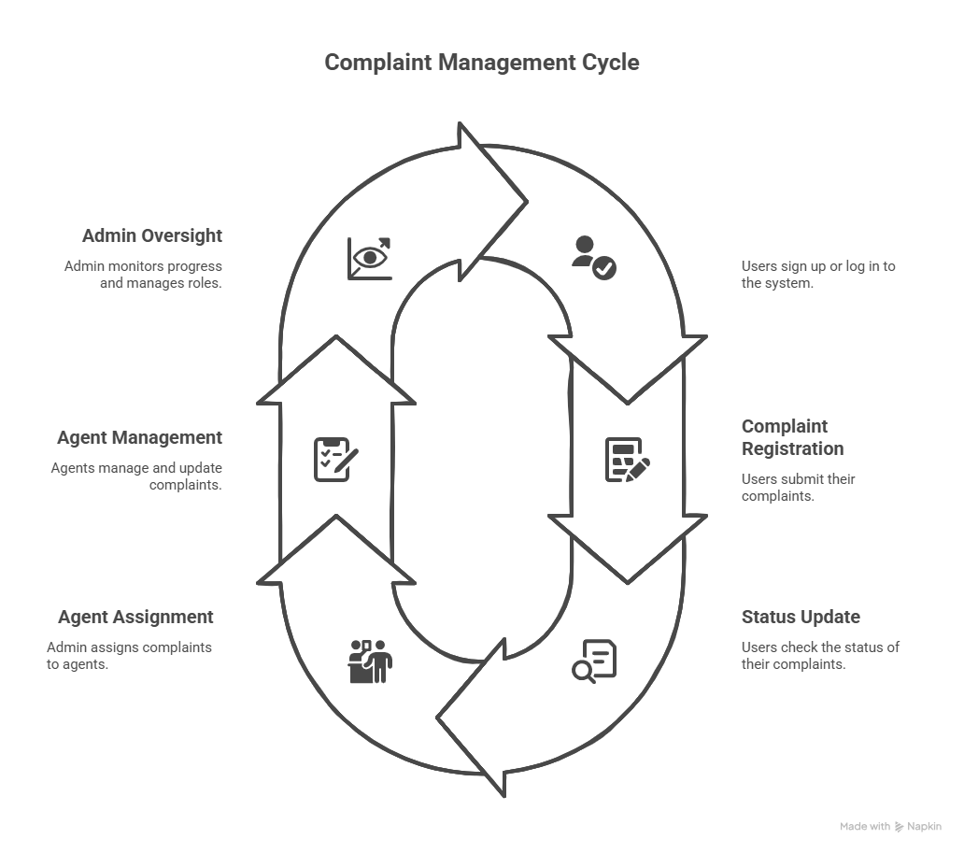

3. Architecture & Tech Stack
🔧 Frontend
Framework: React.js
Routing: React Router DOM
UI Libraries: Bootstrap & React-Bootstrap for responsive and styled components
HTTP Client: Axios – used to communicate with backend REST APIs
🔧 Backend
Runtime: Node.js
Framework: Express.js
API Structure: RESTful APIs exposed via port 8000
Routing: Organized API endpoints for authentication, complaints, assignments, and messaging
🗄️ Database
Type: NoSQL
Engine: MongoDB (supports both local and MongoDB Atlas for cloud)
ODM: Mongoose for schema definition and query building
📘 Mongoose Schemas
User: Stores user credentials, profile info, and role (Admin, Agent, User)
Complaint: User-submitted complaint details including description, status, timestamp
AssignedComplaint: Complaint-agent mapping with current status
Message: Chat messages between users, agents, and admins for a specific complaint
🔐 Security & Middleware
CORS Enabled: Cross-Origin Resource Sharing enabled for frontend-backend communication
Authentication: JWT-based or session-based user authentication
Input Validation: Server-side validation of incoming data
Password Encryption: Passwords are hashed using bcrypt for secure storage
4. Project Setup & Installation
Prerequisites: Node.js (v16+), MongoDB (local/Atlas)
Installation Steps:
Clone: git clone https://github.com/mohangolakoti/complaint-registery.git
Backend Setup:
- cd complaint-registery/backend
- npm install
- node index.js
Frontend Setup:
- cd ../frontend
- npm install
- npm start
5. File & Folder Structure
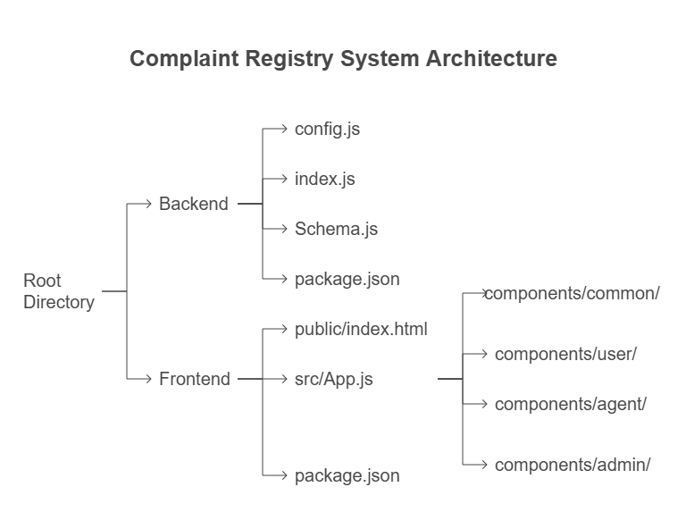
6. System Workflows
ComplaintCare Functional Workflow:
1. 🔐 User Authentication (Signup / Login)
Users sign up or log in through a common interface.
Based on the userType selected (Admin, Agent, or Ordinary User), users are automatically redirected to their respective dashboards:
Admin → /AdminHome
Agent → /AgentHome
User → /HomePage

2. 📝 Complaint Registration (Ordinary User)
Users can register a new complaint using a dedicated form.
Upon submission:
A POST request is sent to the backend API.
Complaint data is saved in the Complaint collection (MongoDB) linked to the user.
Status is initialized as “Pending”.

3. 🧑‍💼 Complaint Assignment (Admin)
Admin dashboard displays all unassigned or newly submitted complaints.
Admin selects an agent for a complaint and assigns it using:
A backend API call that creates an Assigned Complaint record.
Complaint status is set to “Assigned”.

4. 🛠️ Complaint Processing (Agent)
Assigned agents view all complaints linked to them.
Agents can:
A Update complaint status: In-Progress, Resolved, or Closed.
Access a real-time chat interface to communicate with the user and/or admin regarding the issue.

5. 📊 Complaint Tracking & Interaction (User)
Logged-in users can:
Monitor the real-time status of their complaints (using Status component).
Engage in two-way chat with the assigned agent to get updates or provide additional info.
View complaint history and current status anytime.
7. API Endpoint Documentation
POST /api/signup – Registers new user.
POST /api/login – Authenticates user.
POST /api/complaints – Registers a new complaint.
GET /api/complaints/user/:userId – Gets user complaints.
PATCH /api/complaints/assign – Assign complaint to agent.
GET /api/complaints/assigned/:agentId – Agent's assigned list.
PATCH /api/assigned/:id/status – Updates complaint status.
POST /api/messages – Sends chat messages.
8. Authentication & Authorization
Signup
Users can register by providing details such as name, email, phone number, and password.
During signup, the user selects a role from the following options:
Ordinary User
Agent
Admin
The selected role (userType) determines access and dashboard redirection.
Login
Upon successful login, the backend issues an authentication token (JWT or session-based, depending on implementation).
This token is used to authorize subsequent requests to protected routes.
Role-Based Route Protection
Routes are protected based on user roles to ensure restricted access:
Ordinary Users can access complaint registration, status, and chat components.
Agents can access only their assigned complaints and messaging.
Admins can manage users, agents, and complaint assignments.
Unauthorized access attempts redirect the user or block the request with appropriate error handling.
9. User Interface & Screens
Include screenshots of Home page, Login, Signup, Dashboards (User/Admin/Agent), Complaint form, Chat window.

Auth Pages

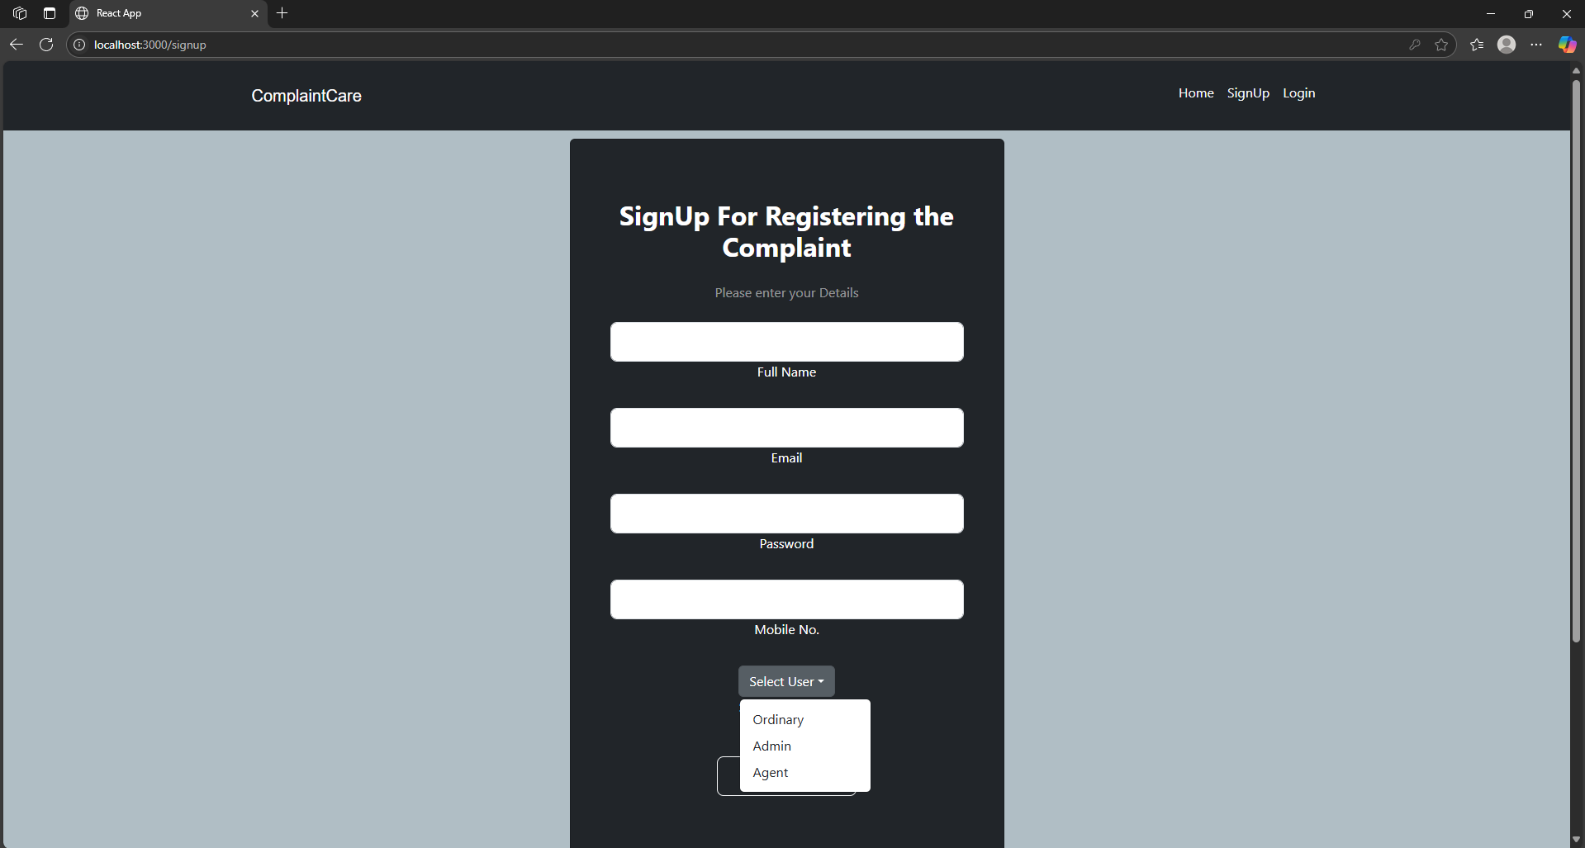

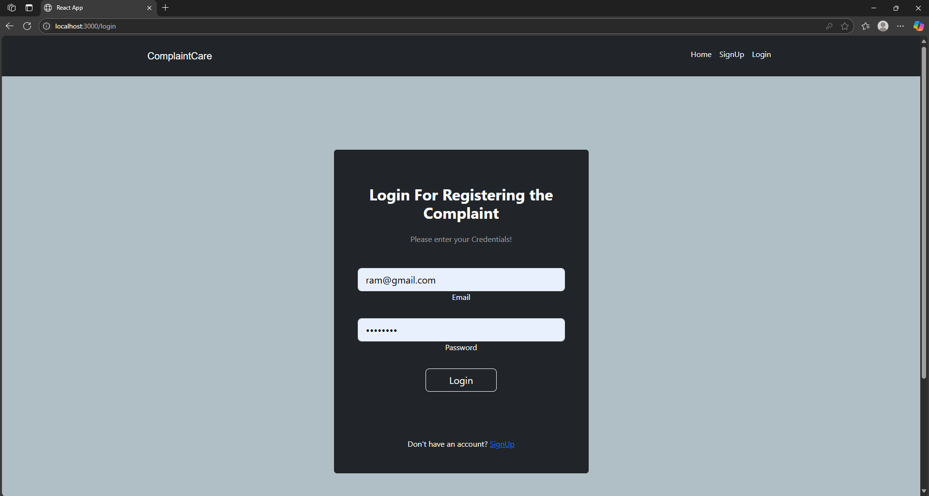
User Dashboard

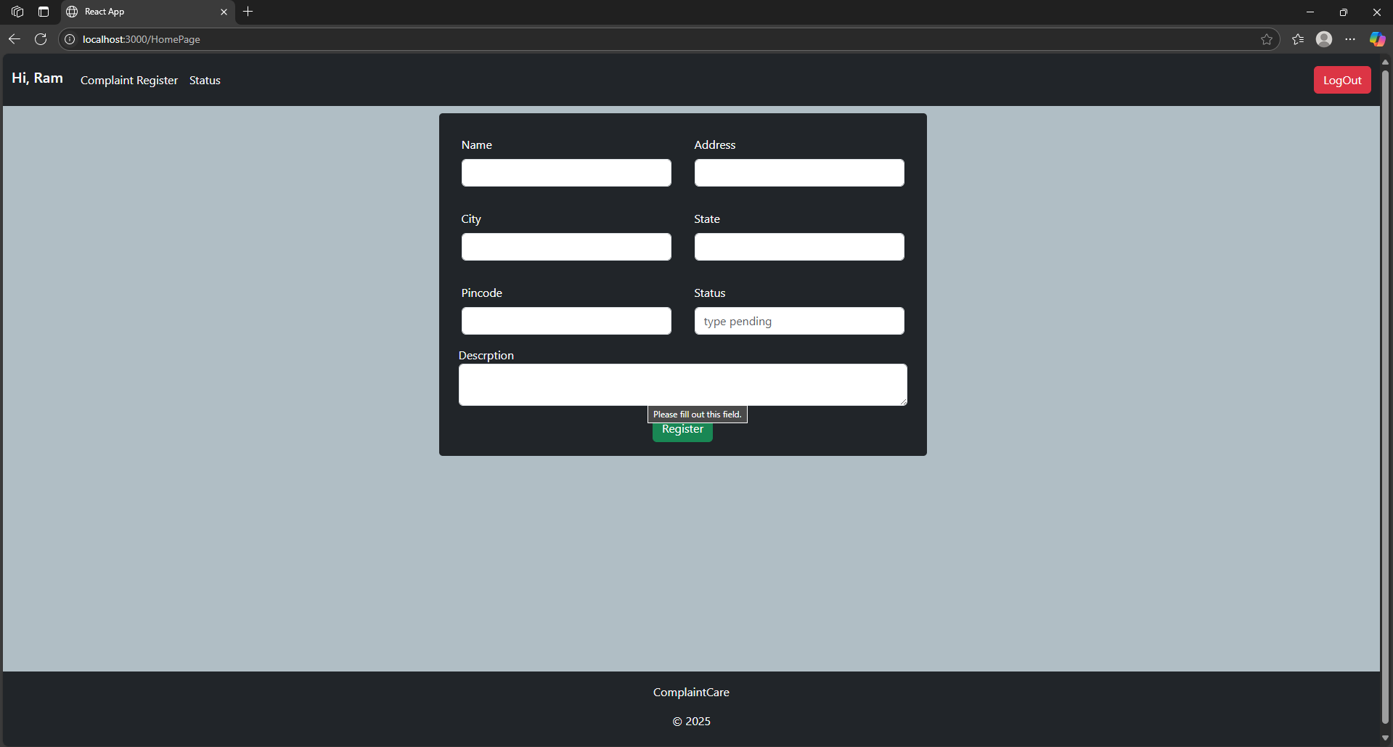
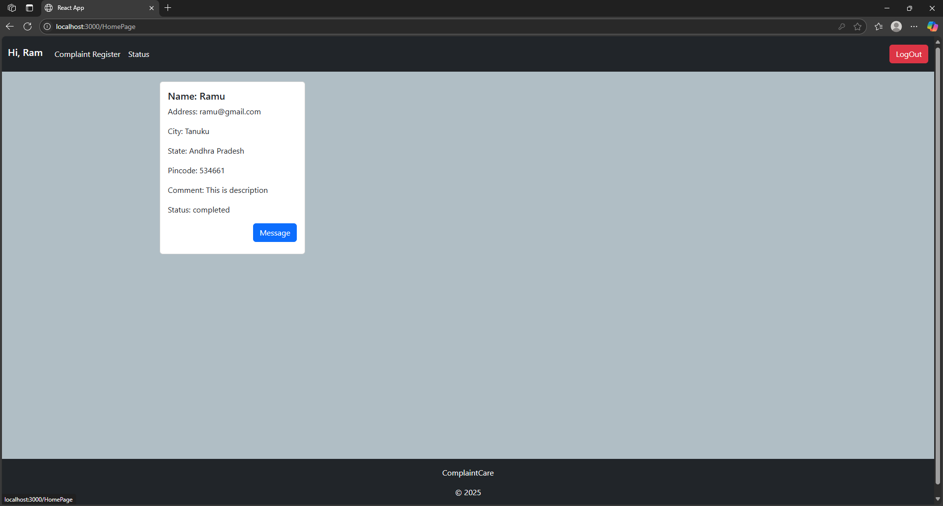

Admin Dashboard

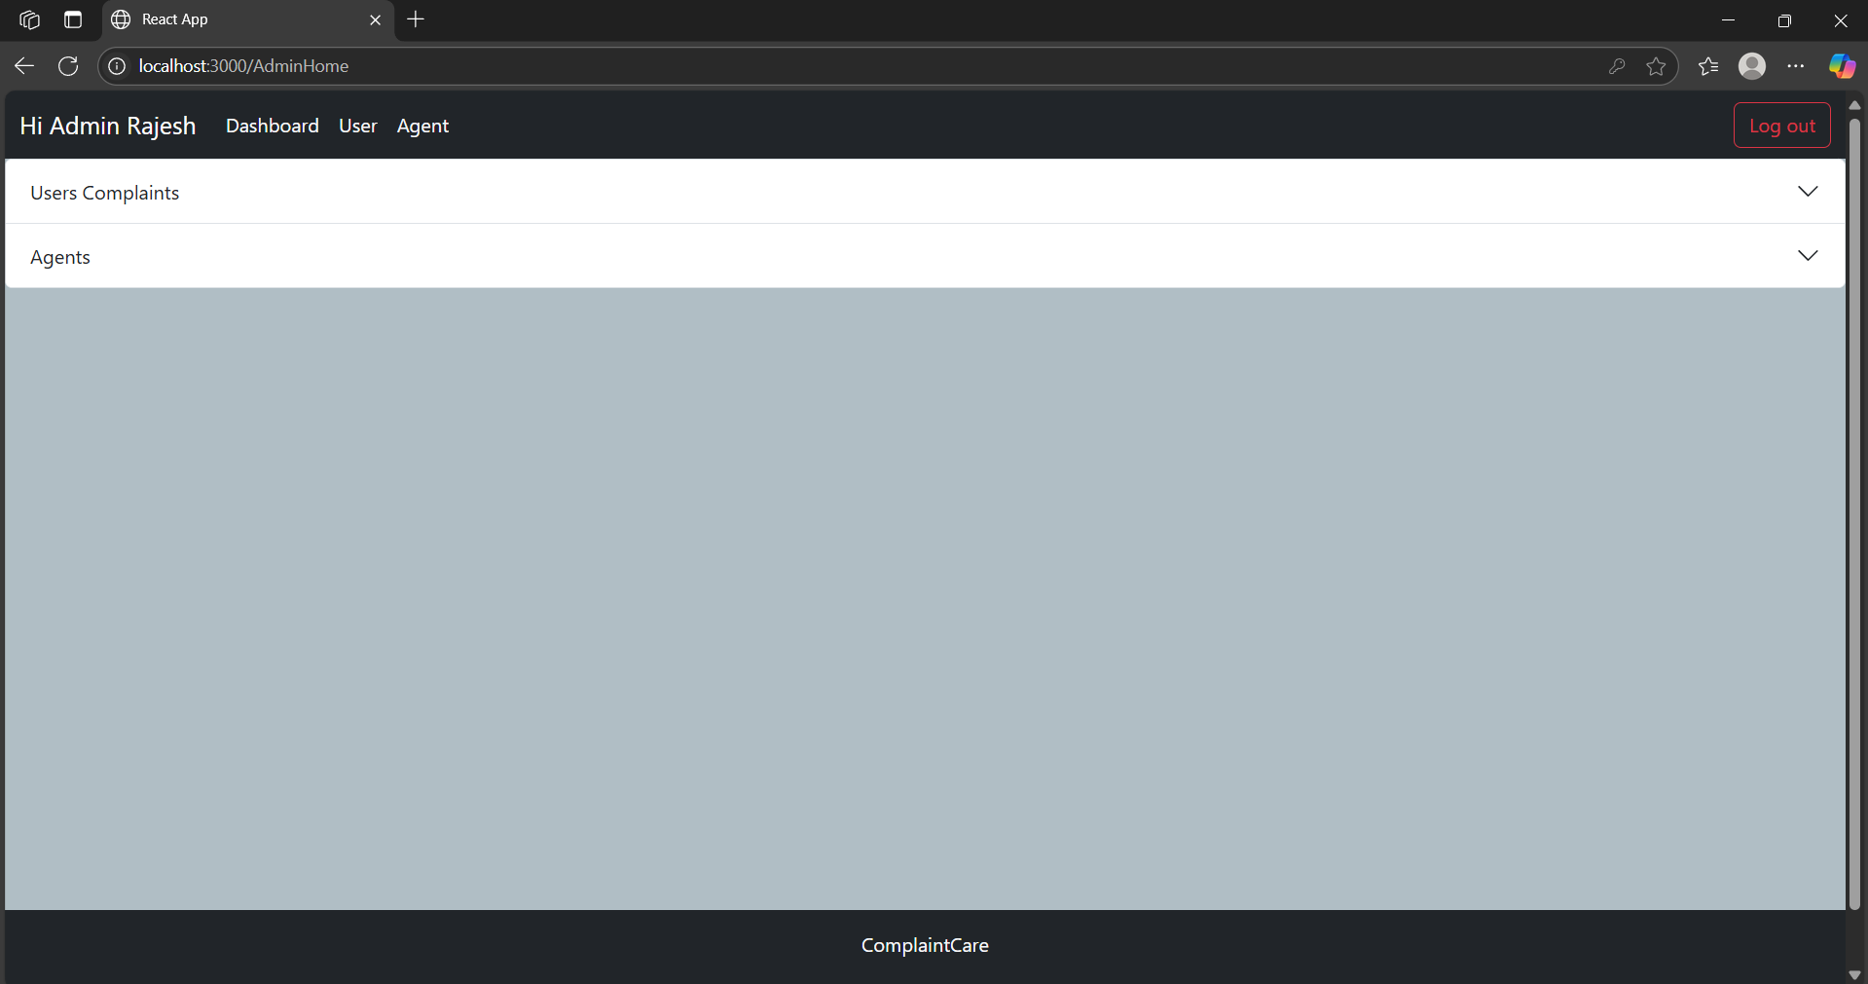
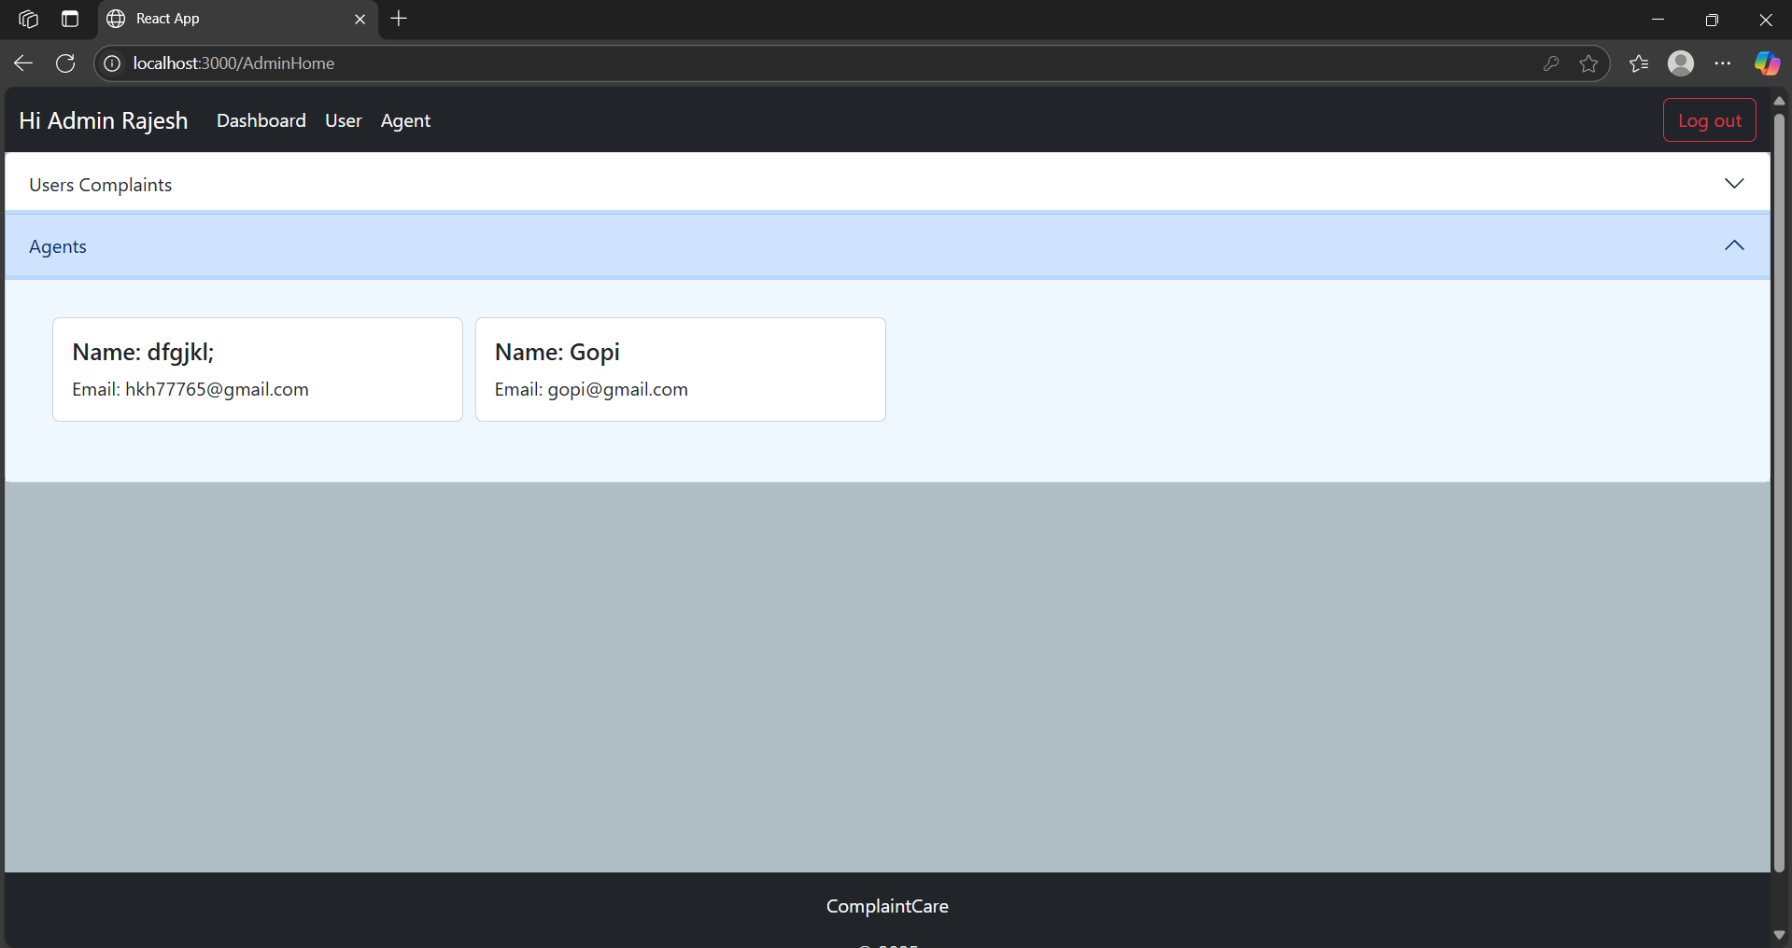

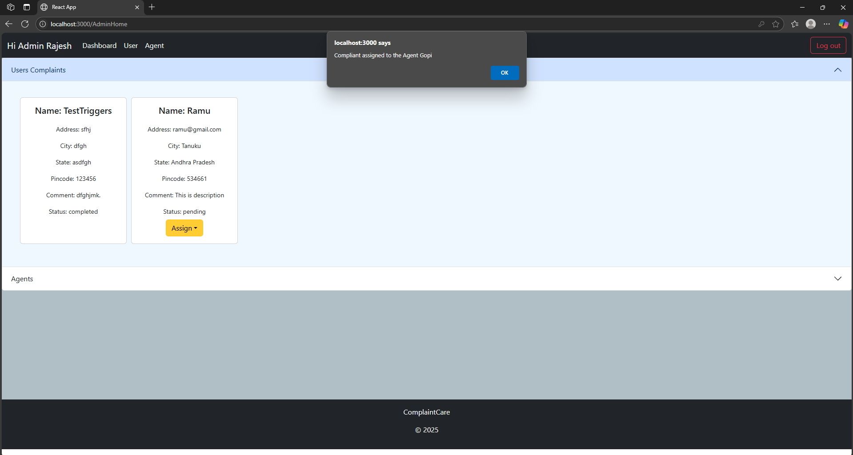

Agent Dashboard
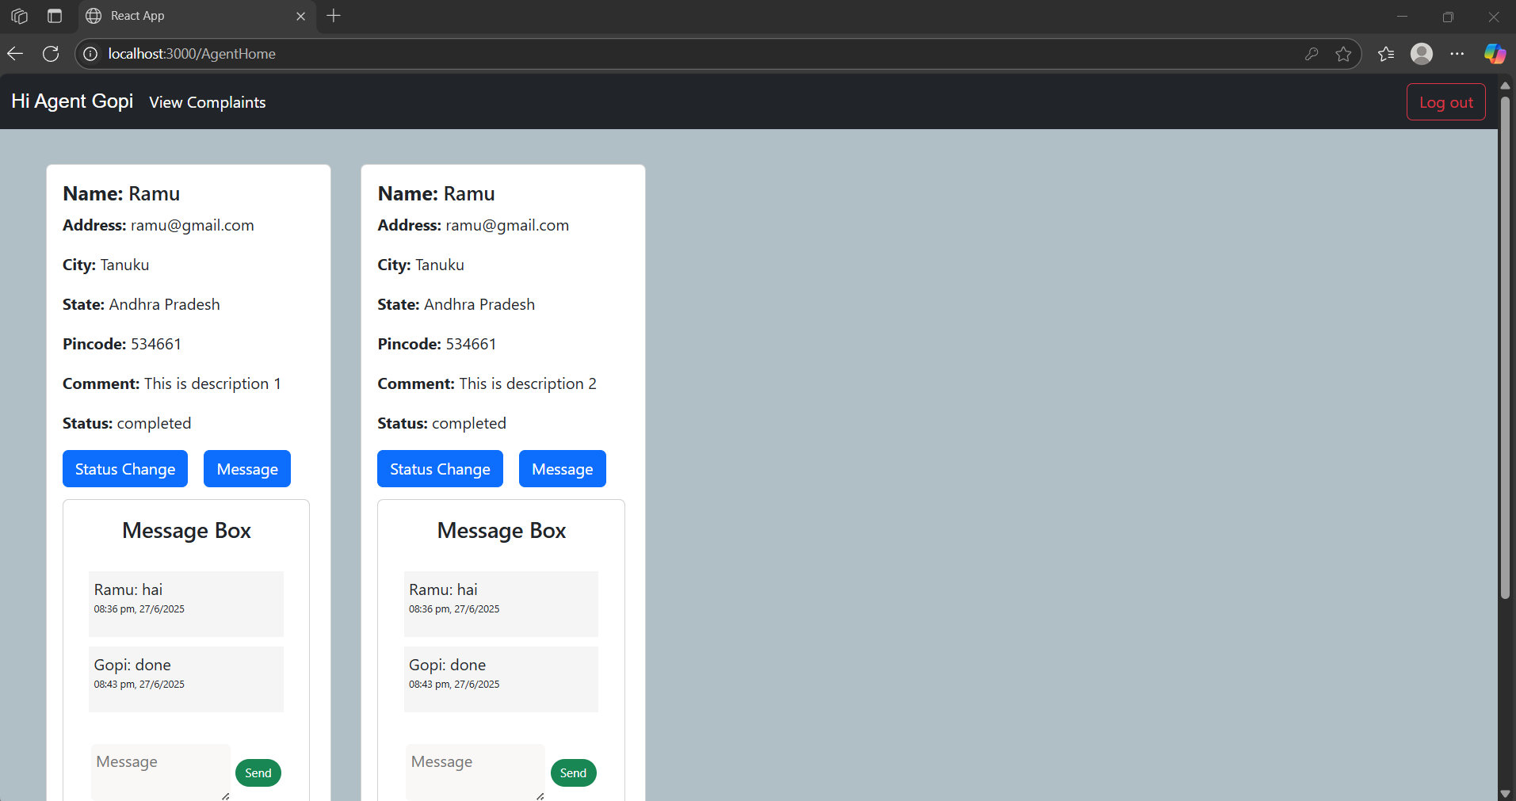

10. Testing Strategy
Manual Testing
Each user role (Admin, Agent, and Ordinary User) was manually tested to ensure:
Correct redirection after login
Access to appropriate dashboard and features
Smooth execution of workflows like complaint registration, assignment, tracking, and chat
API Testing with Postman
RESTful API endpoints were tested using Postman to validate:
Request/response structure
Data integrity between frontend and backend
Proper status codes and error handling
Role-based access restrictions on protected routes
11. Known Issues
Despite the core functionality being complete and stable, a few areas are identified for improvement in future versions:
No Email Notification Support
The system currently does not send automated email notifications to users or agents for complaint updates, assignments, or messages.
No Real-Time Unread Message Indicators
While real-time chat functionality is implemented, the UI does not yet display unread message indicators or notification badges for pending messages.
Minimal Front-End Validation
Basic validation exists for required fields (e.g., login, signup, complaint forms), but more robust checks (e.g., format validation, client-side error prompts) are minimal or missing.
12. Future Enhancements
Email/SMS notification support.
Real-time WebSocket chat.
Analytics dashboard for Admin.
Mobile responsiveness improvements.
Advanced search/filter options.
13. Appendix
MongoDB Schemas from Schema.js.
Sample payloads for API endpoints.
Frontend screenshots in frontend/src/Images/screenshots/.

